
ITE231 | WEEK 5 ACTIVITY
API Integration & HTTP Requests
EverCare OpenStreetMap Hospital Finder
Student: Brent Lawrence C. Bernardo
Section: ITE231
Professor: Paul John Cabance
Prepared: August 15, 2026
Due: August 17, 2026 at 7:00 PM
IMPLEMENTATION OUTCOME
EverCare already contains a complete external API integration. Live verification returned HTTP 200 from both GET and POST requests, with 15 Nominatim search records and 75 Overpass hospital elements. The app displayed the processed results on the map and in the appointment workflow.

GitHub repository (submitted instead of a source-code ZIP): https://github.com/Brentttttttt/evercare
This document provides the API purpose, endpoints, request methods, JSON-processing evidence, live UI screenshots, and verification results required for Week 5.

1. Integration Overview
The OpenStreetMap Hospital Finder gives caregivers a practical way to find nearby hospitals, search by hospital or place name, see returned locations on a map, and select a hospital while creating an appointment. The same hospital finder is also available from EverCare's Emergency page.

How the integration works
- The user searches by name or requests nearby hospitals from the EverCare interface.
- HospitalFinderService sends a rate-limited HTTP GET or a form-encoded HTTP POST request.
- The service validates and decodes the JSON response, maps records to HospitalLocation objects, removes duplicates, and calculates distance when a device position is available.
- HospitalFinderScreen displays markers, names, addresses, distances, loading states, and retry guidance. Selecting a result fills the appointment hospital and address fields.

APIs and endpoints
API | Endpoint | Method | Purpose
Overpass API | https://overpass-api.de/api/interpreter | POST | Find hospitals within a 15 km radius; two fallback providers are configured.
Nominatim Search | https://nominatim.openstreetmap.org/search | GET | Search Philippine hospitals and places after the user submits a query.
Nominatim Reverse | https://nominatim.openstreetmap.org/reverse | GET | Resolve a missing address for a selected result.
Photon | https://photon.komoot.io/api | GET | Provide debounced search-as-you-type hospital suggestions.
OSM Tiles | https://tile.openstreetmap.org/{z}/{x}/{y}.png | GET | Render the in-app map with visible OpenStreetMap attribution.

WHY THIS API IS USEFUL
The integration reduces manual typing, makes hospital locations easier to review, and connects appointment planning with nearby-care discovery. It does not require a paid API key.

2. Week 5 Requirements Compliance
Requirement | EverCare evidence
Integrate at least one API | OpenStreetMap hospital discovery uses Overpass, Nominatim, Photon, and OSM tiles.
HTTP GET requests | Nominatim search/reverse and Photon autocomplete use http.Client.get with headers and timeouts.
HTTP POST requests | Overpass uses http.Client.post with a form-encoded data field containing the bounded hospital query.
Parse JSON responses | jsonDecode validates object, list, and GeoJSON response shapes before typed mapping.
Display dynamic API data | Hospital markers, result counts, names, addresses, and distances are rendered in the finder.
Handle loading and invalid responses | The UI provides progress, empty, permission, API error, and Try Again states. The service reports malformed JSON honestly.
Brief API explanation | Purpose, endpoints, methods, processing, limitations, and tests are documented here.
Updated source code | The GitHub repository link is supplied in place of a source ZIP, as requested.

Request safeguards
- Identifiable EverCare User-Agent and JSON Accept headers.
- One-second serialization for public geocoder requests and 900 ms UI debounce for typing.
- Bounded result limits, a 15 km nearby radius, and in-memory caching.
- Timeouts plus fallback Overpass providers for HTTP 429, server failures, and network errors.
- Philippines-only filtering for submitted searches and autocomplete suggestions.
DATA AND SAFETY NOTE
The submitted evidence uses a generic public Guiguinto location and contains no patient data, credentials, keys, or precise user location. OpenStreetMap results may be incomplete or outdated and do not confirm hospital availability, capacity, contact accuracy, or quality of care.

3. HTTP POST Implementation
EverCare builds an Overpass QL query for amenity=hospital or healthcare=hospital, sends it as application/x-www-form-urlencoded, verifies the HTTP status, then decodes the JSON object and reads its elements array.
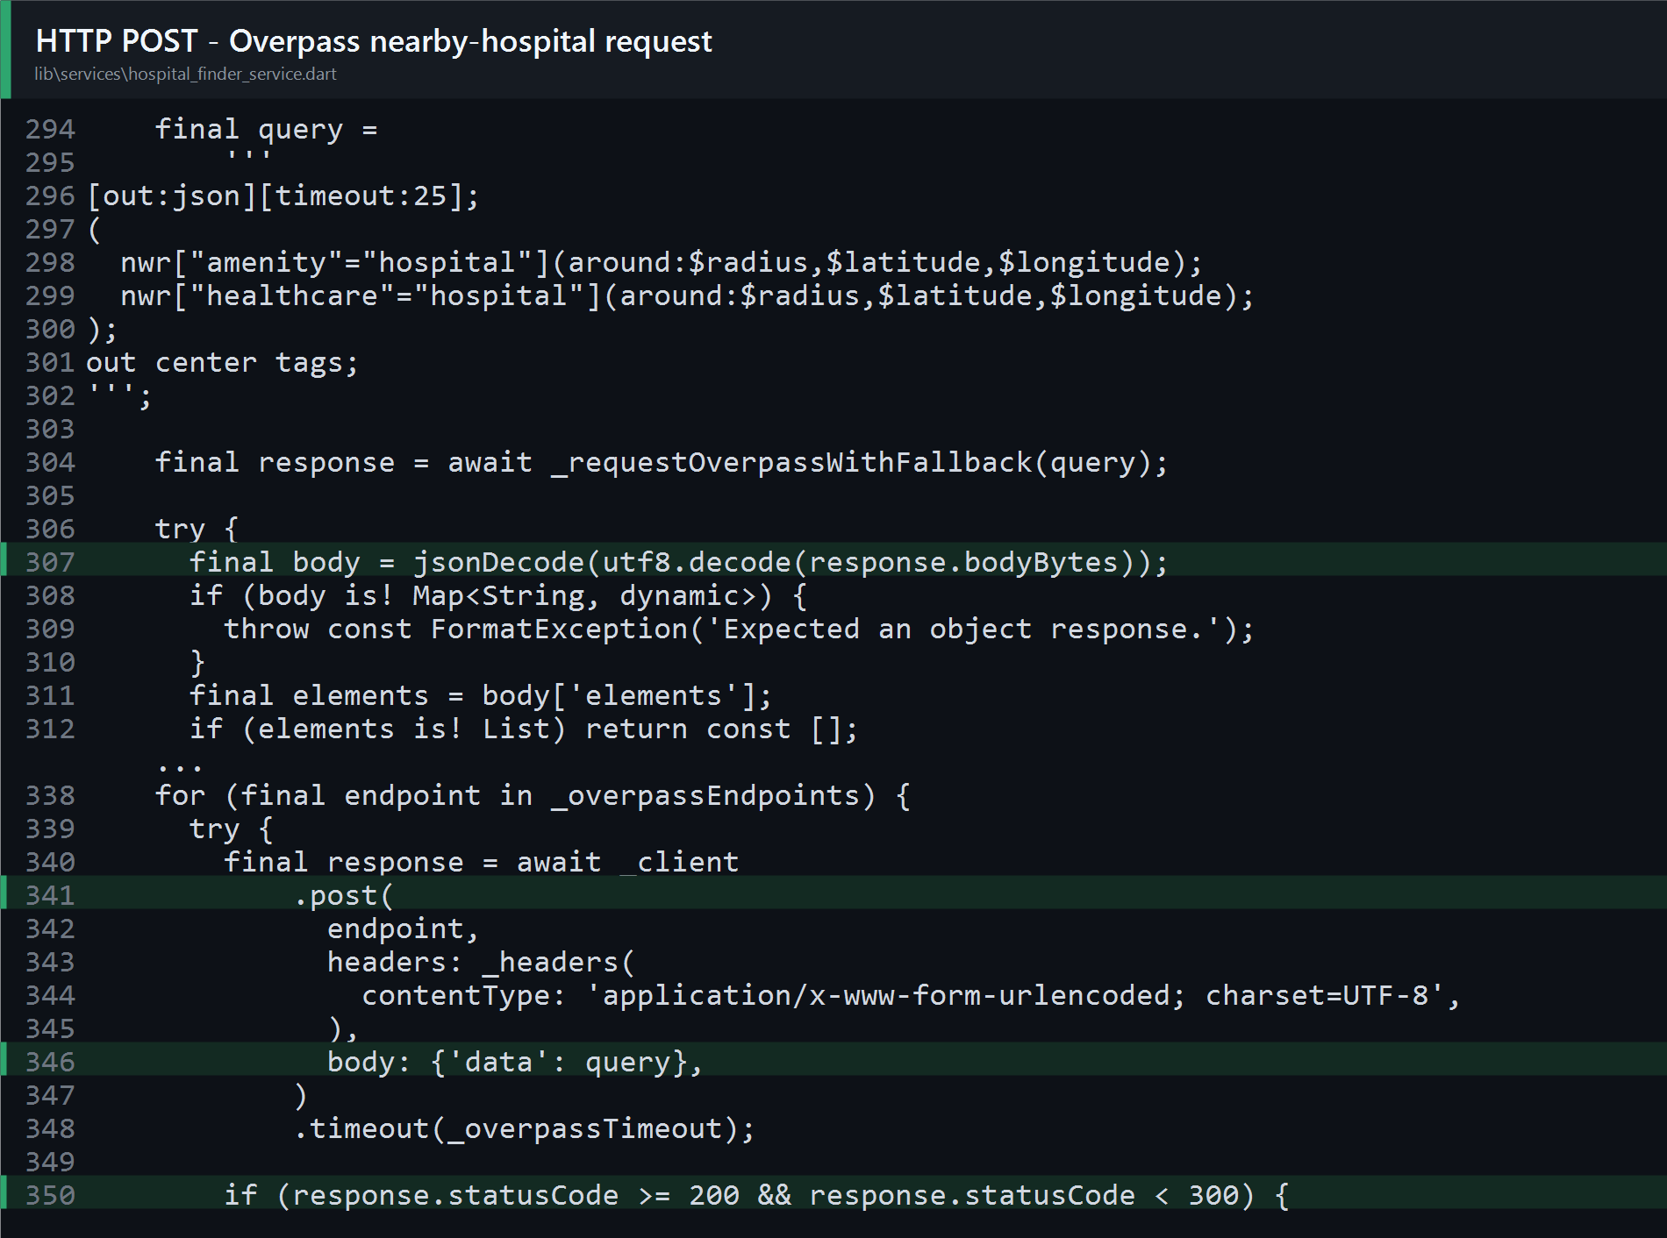
Figure 1. Actual EverCare source showing the Overpass POST request, JSON decoding, and successful-status check.
Live result: HTTP 200 with 75 OpenStreetMap elements around the public Guiguinto demonstration center. EverCare deduplicates, sorts, and displays up to 25 nearby results.

4. HTTP GET and JSON Processing
A submitted search builds a Nominatim URL with jsonv2 output, Philippine country filtering, address details, a bounded result limit, and deduplication. The response must be a JSON array before each item is mapped to a HospitalLocation.
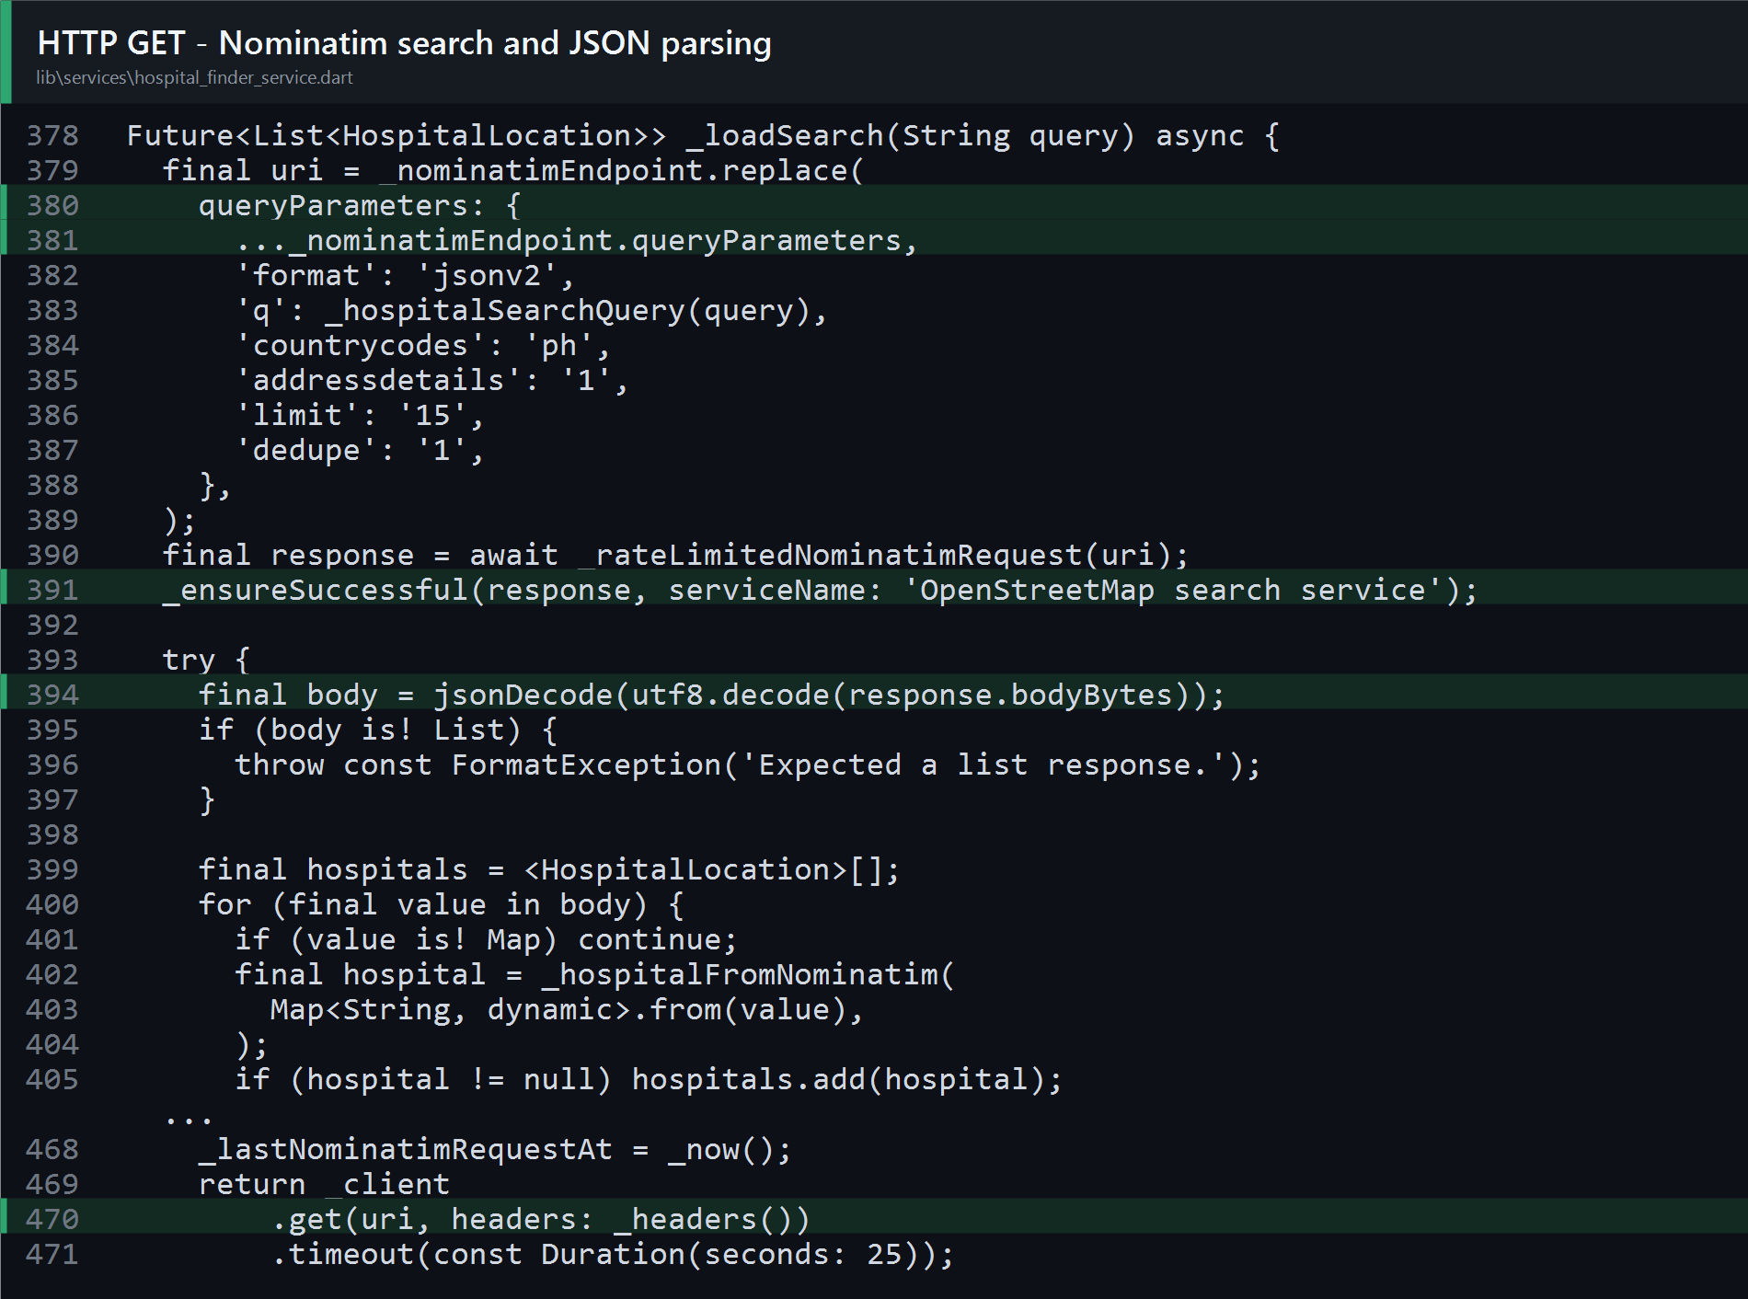
Figure 2. Actual EverCare source showing Nominatim GET parameters, status validation, jsonDecode, and typed mapping.
Live result: HTTP 200 with 15 hospital and place records for the submitted query “hospital, Bulacan, Philippines.”

5. Retrieved API Data in EverCare
The nearby flow uses device location only after permission is available, performs the Overpass POST, and displays processed results with map markers and distance labels.
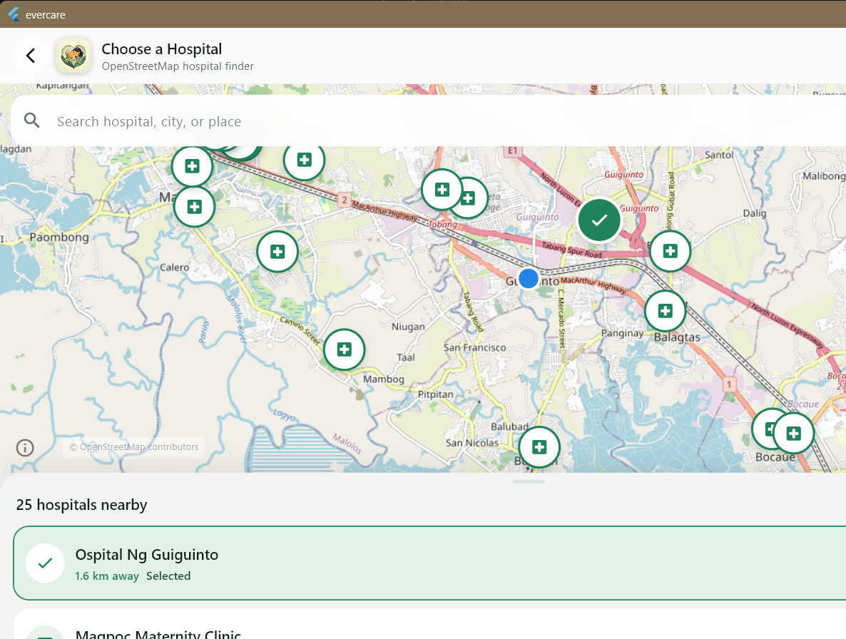
Figure 3. Live EverCare hospital finder showing 25 nearby processed results, map markers, OpenStreetMap attribution, and a selected hospital.
MEANINGFUL DISPLAY
Raw JSON is not shown directly to the caregiver. EverCare converts it into readable hospital cards, coordinates, addresses when available, distance labels, and interactive map markers.

6. Search and Appointment Workflow
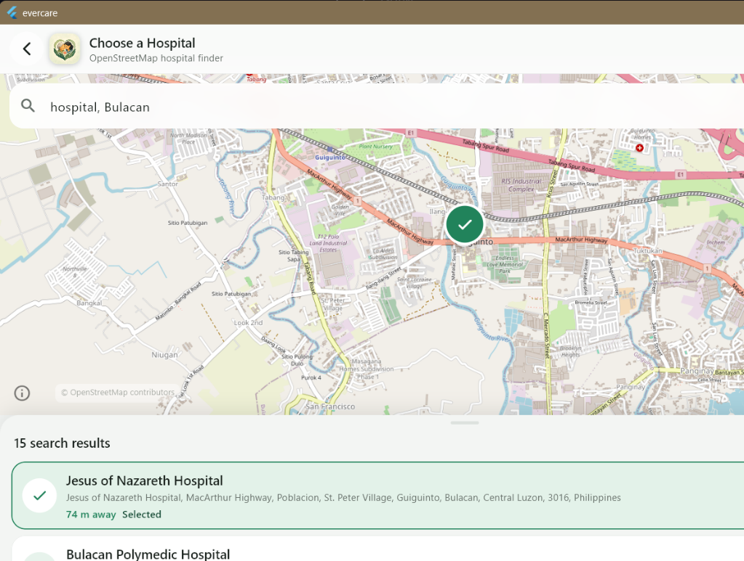
Figure 4. Submitted GET search displaying 15 named Bulacan results, including a selected result and distance.
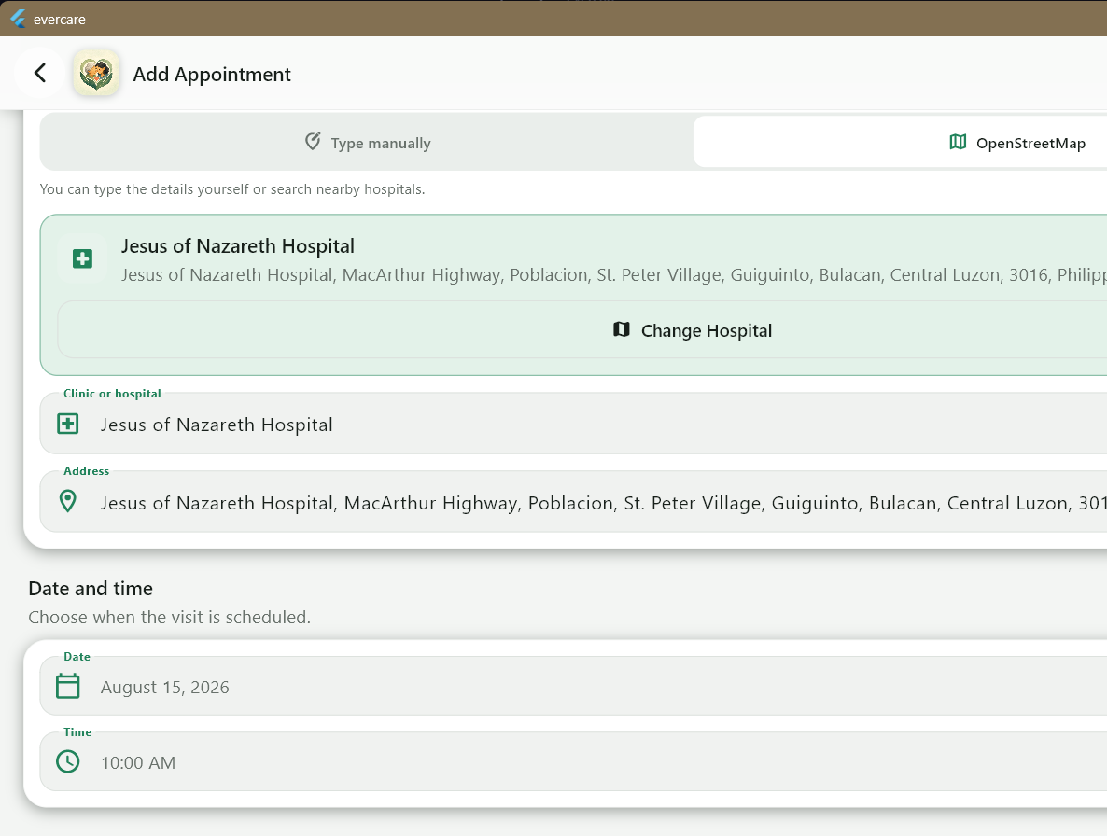
Figure 5. The selected API result automatically fills both the Clinic or hospital and Address fields.

7. JSON Response Sample
The following excerpt was generated from the live Overpass HTTP 200 response. The complete response and a separate Nominatim JSON array are included in api_samples.
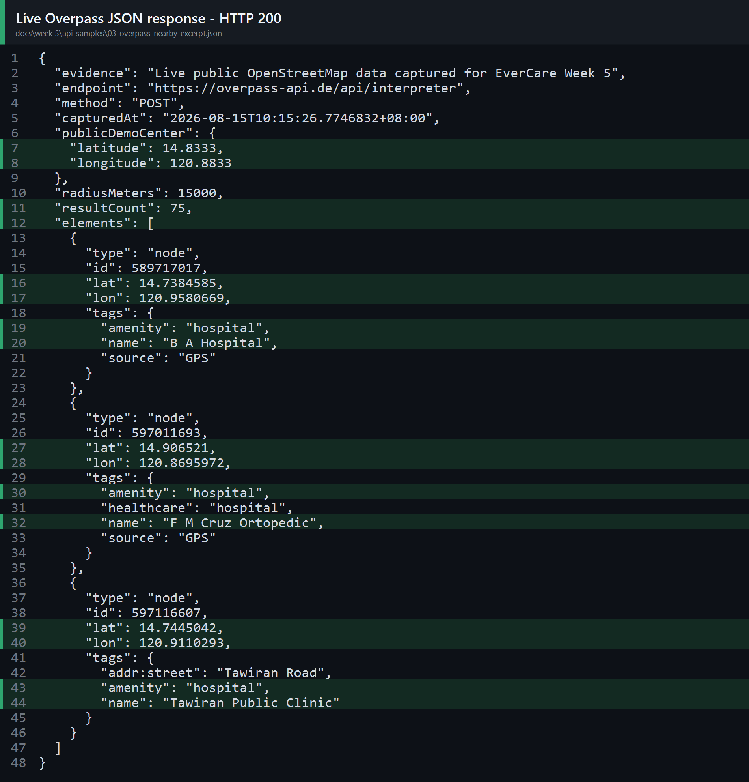
Figure 6. Genuine Overpass JSON excerpt containing the request method, result count, coordinates, hospital tags, and names.
Full GET sample: api_samples/01_nominatim_search_response.json
Full POST sample: api_samples/02_overpass_nearby_response.json

8. Loading, Error Handling, and Verification
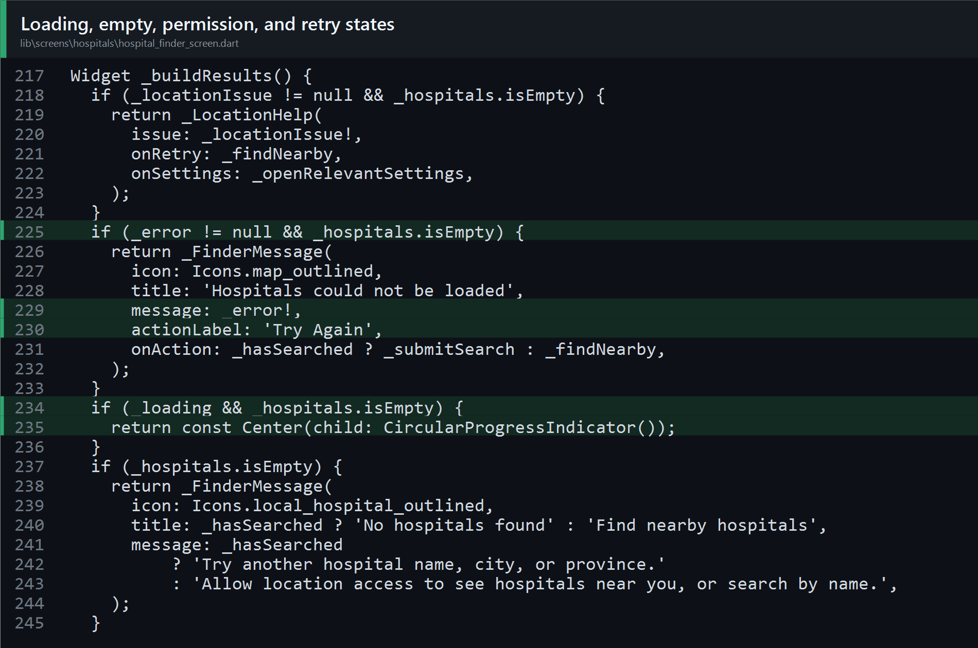
Figure 7. Actual UI code for permission guidance, loading progress, empty results, API errors, and the Try Again action.

Verification results
- flutter analyze: PASS - no issues found.
- flutter test: PASS - all 99 tests passed.
- HospitalFinderService tests: PASS - all 10 tests passed.
- Windows debug build: PASS - evercare.exe built successfully.
- Live Nominatim GET: HTTP 200 - 15 JSON records.
- Live Overpass POST: HTTP 200 - 75 JSON elements.

Submission checklist
- Final PDF documentation included.
- Request-code, retrieved-data, and JSON-response evidence included.
- API name, endpoints, methods, purpose, and features documented.
- GitHub repository link included; no source ZIP included by request.
GitHub repository: https://github.com/Brentttttttt/evercare
CONCLUSION
EverCare meets the Week 5 expected output with a working API integration that retrieves, sends, processes, and displays dynamic hospital data while handling network and response problems safely.

